USER MANUAL

This documents refers to usage instructions about the software “Equipment Reservation System”.

These are the following function requirements and corresponding description.

**1 .Transections performed Admin**

1.

TITLE: Admin Login

Given that the admin is on the main web page, there shall be a login button on this page. Clicking on the login button takes the admin to the main login page. This page will look like this.

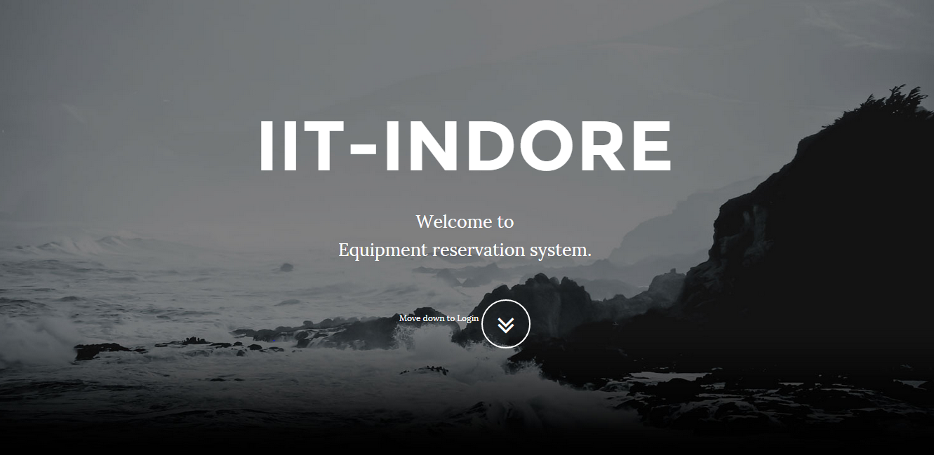

2.

TITLE: Logging in

DESC: On the main login page the admin has to input his username, password, and from a checklist select that he is the admin. There shall be an ‘OK’ button on this page to enable logging in and page will look

This.

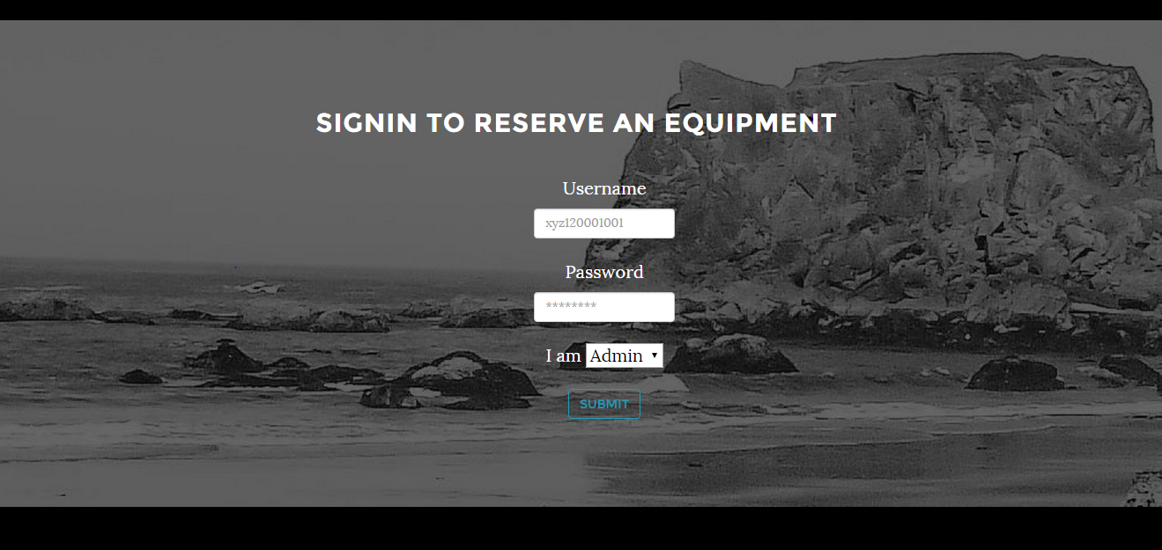

By clicking on “Submit” button takes Admin to the Admin main where Admin can perform a number of transections , like, “Add User”, ”Delete Users” and many more transections. Here we have screen shot of this page.

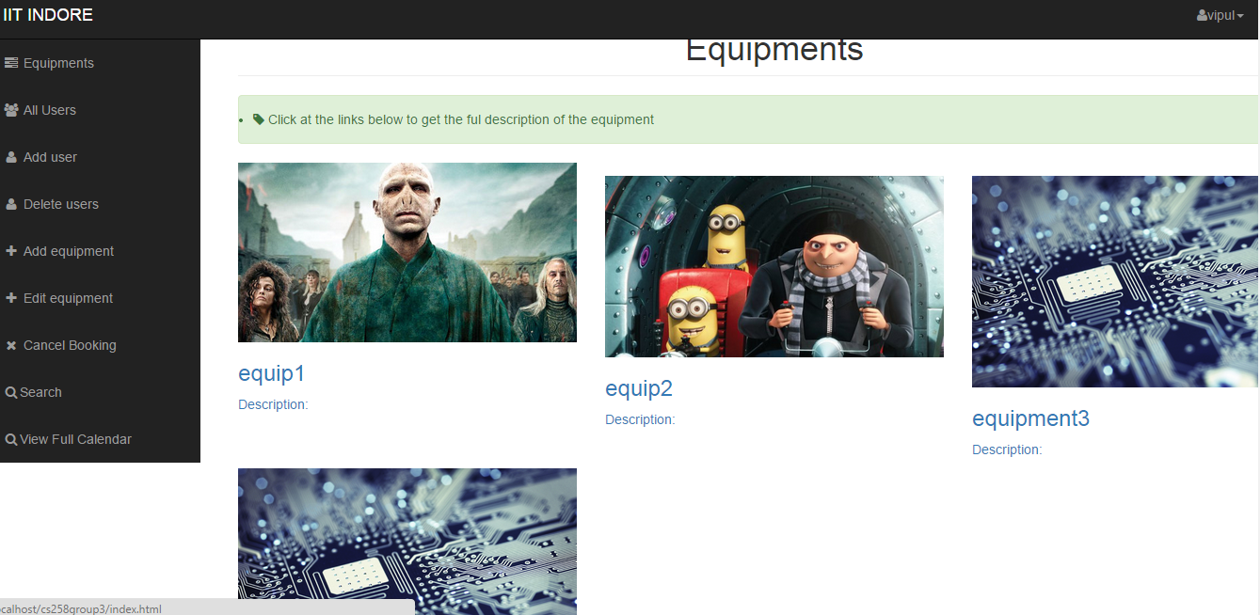

Now on left side of this page Admin will have different links for different transections.

1. By clicking on First Link “Equipments” will takes the Admin on same page.

Here admin can click on any equipment.This will take admin to the calendar view of the corresponding equipment(current month).Here green coloured box indicates the current date.there are more functionalities also.

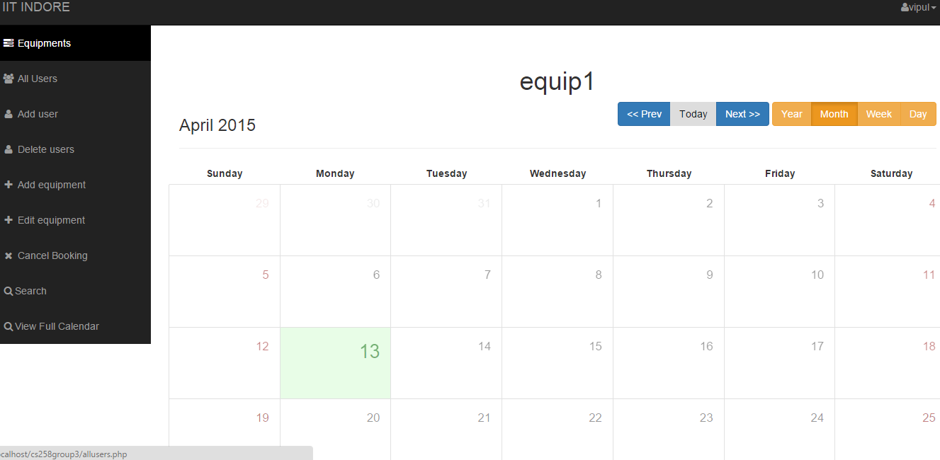

On right side there many buttons, like,

Prev – will show the previous months’ calender.

Next - will show the next months’ calendar.

Today – Green box indicates about today.

Year - It will show months of current year and corresponding booking will be denoted by *red colour*;

Month – It will the calendar of current month.

Week - It will show the current week and details regarding

Every day.

Now By double clicking on valid date will take to the time slot of the date. Then click on “add a Booking”.

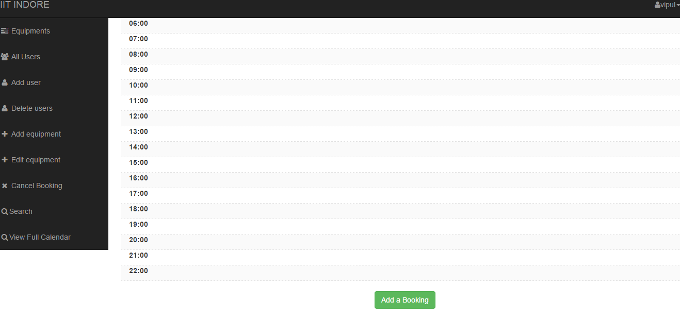

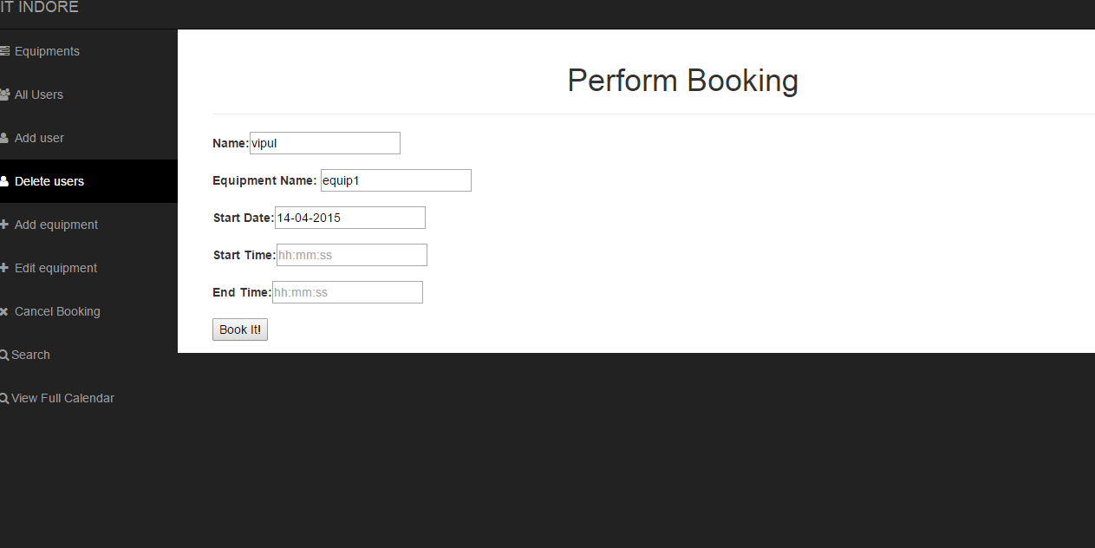

Fill valid *Start and End Time*. and make a booking.

After booking it will show Success message.

At the right top you have profile setting option.

1. Second link “All Users” will takes to the page where Admin can see All users and their details. Which will look like as follows.

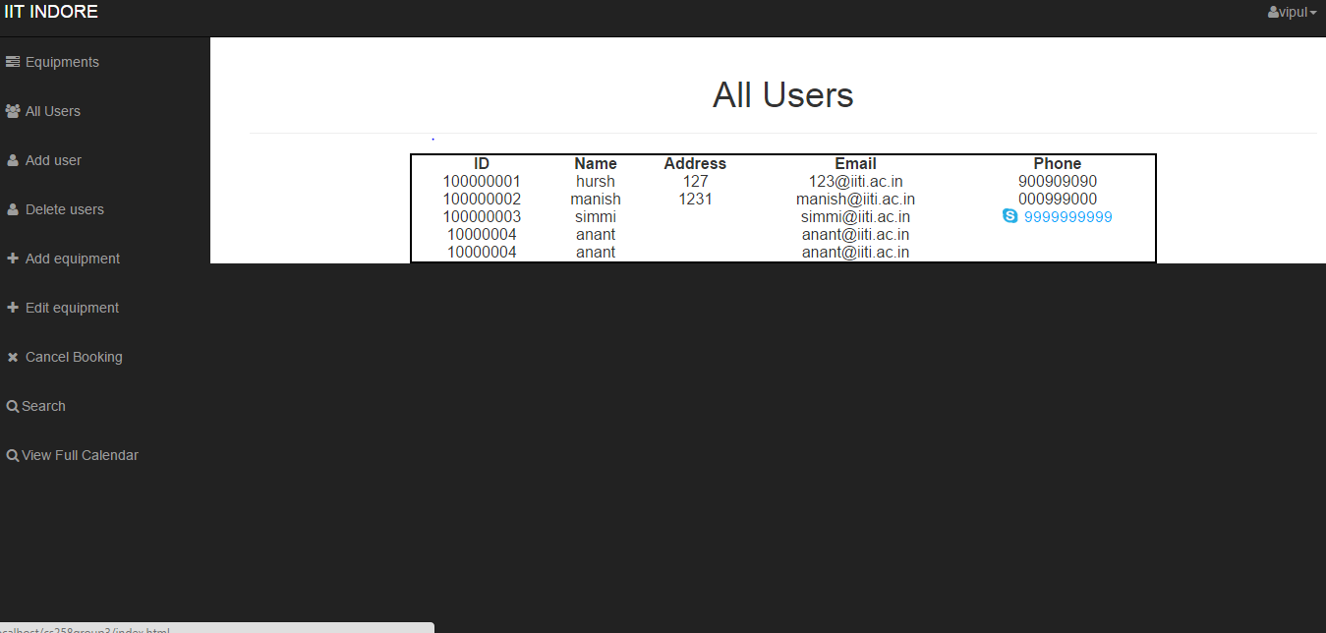

1. “Add user” will take to the page which will show the *New User Requests* for booking as below.

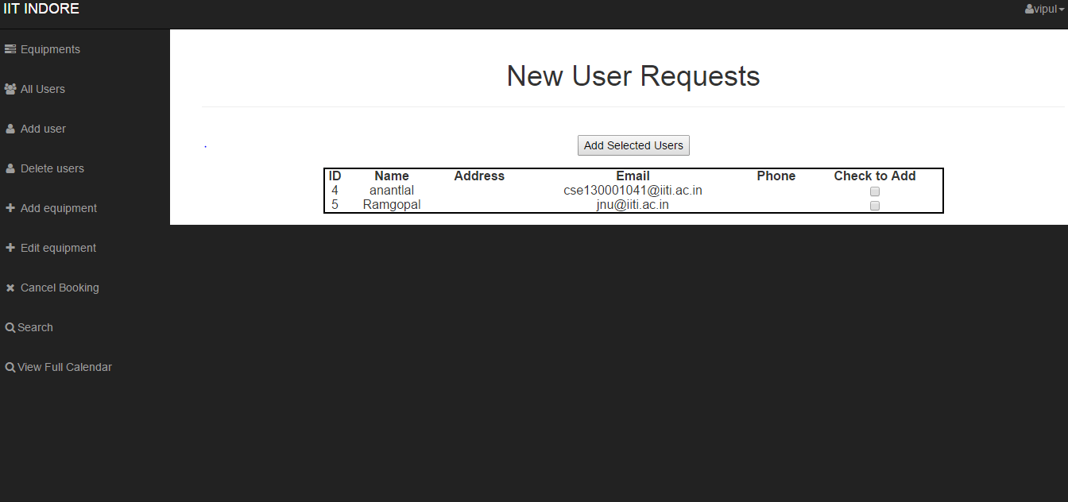

Now Admin can select the user by clicking on “***Add to check***”

Whom he wants to add.

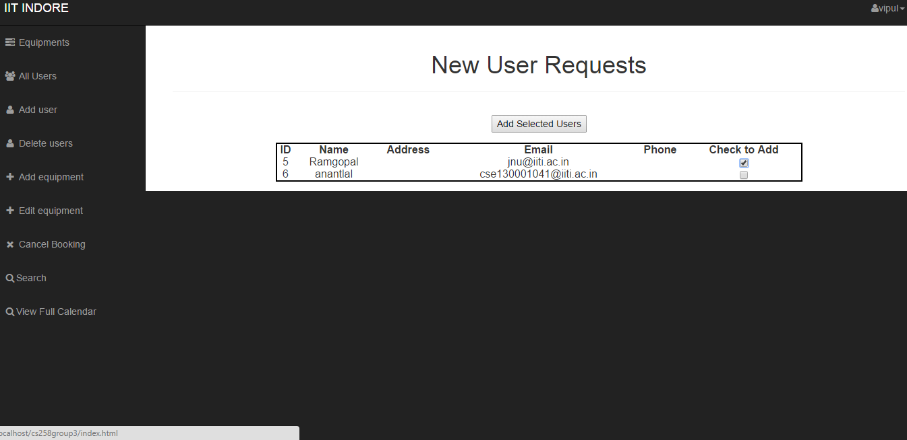

After that by clicking on “***Add selected Users***” will add the selected users and will show the same page as for (ii) but with additional users than earlier as one can see .

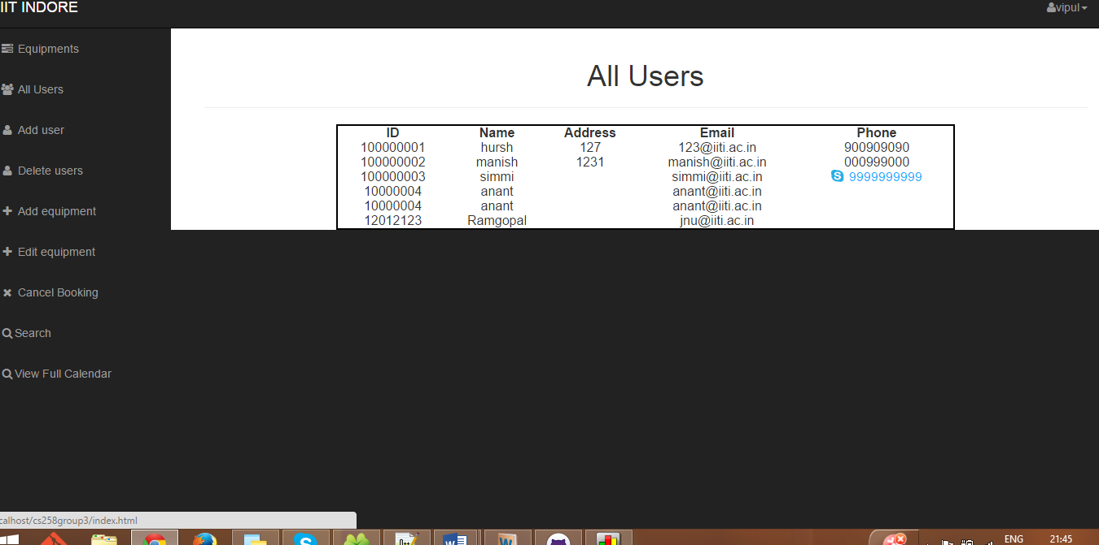

1. Now at “***Delete Users***” page Admin will tick-out the user to be deleted as follows.

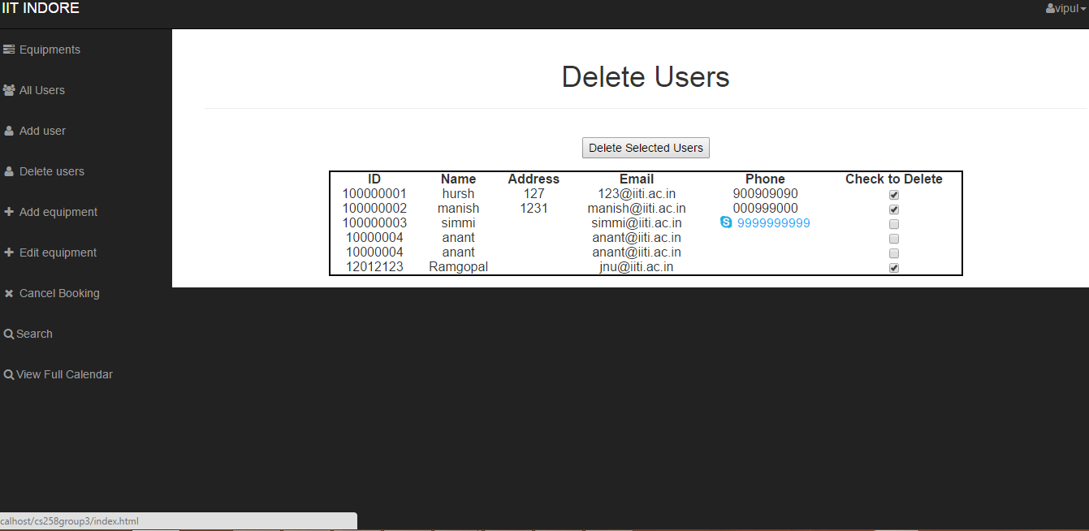

And then clicking on “***Delete selected users***” will delete the

seleted users will show the same page as for (ii) but with

less number of users than earlier as one can see .

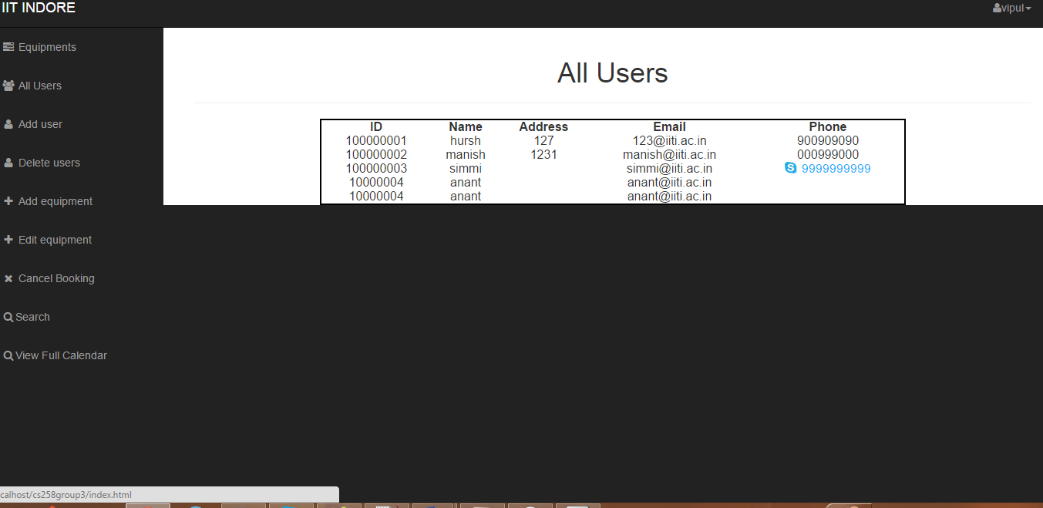

1. Clicking on “***Add Equipment***” a new unfilled page will be open.

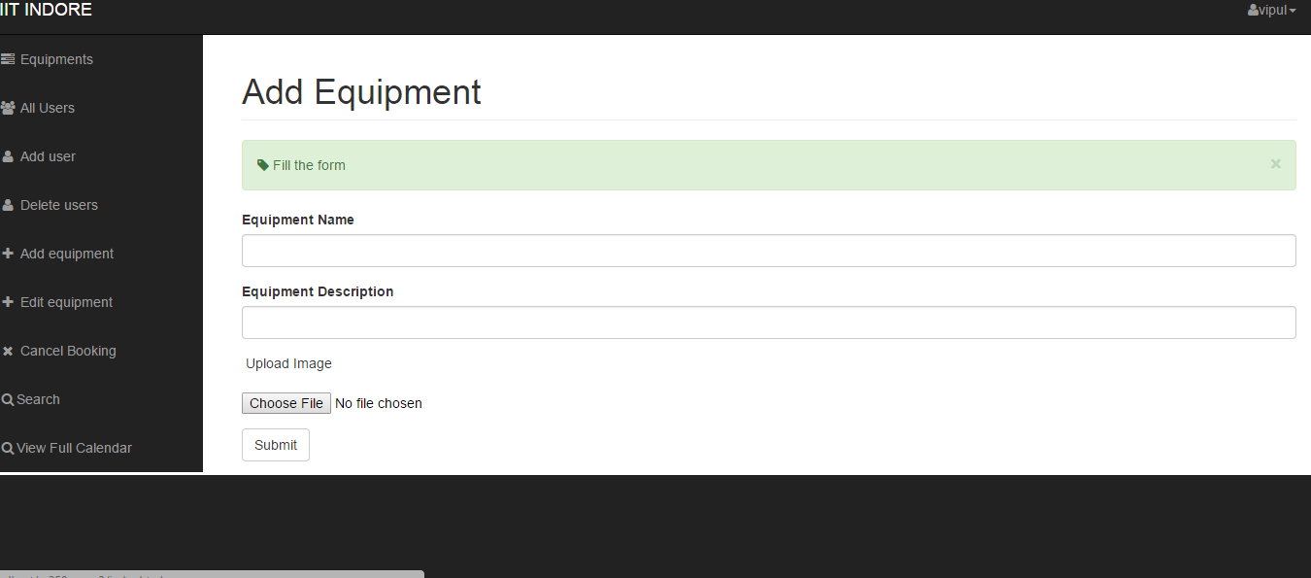

Here Admin will have to fill the form and have to upload the image of equipment by “choose file” button and then after submitting Equipment will be added. It can be seen again on clicking “***Equipments***” at the top left corner.

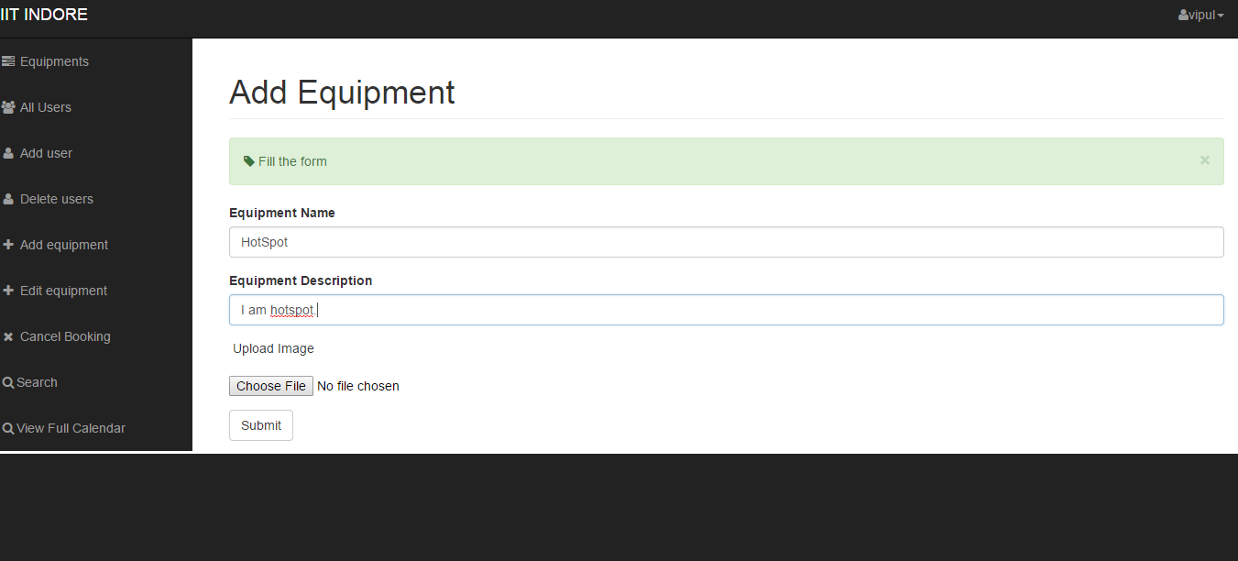

No file has been chosen.

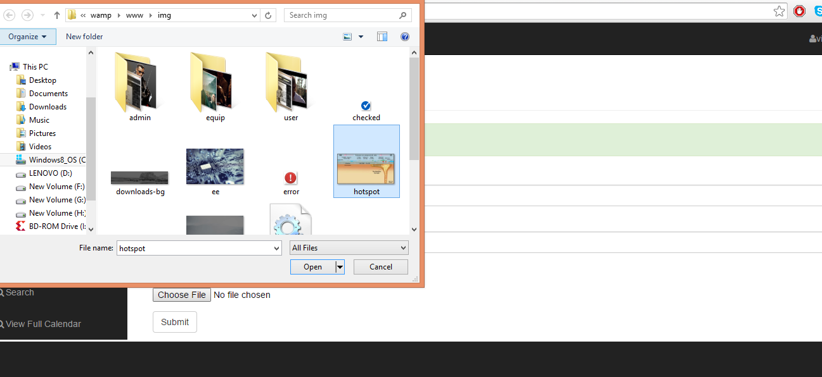

Again No file has been chosen.

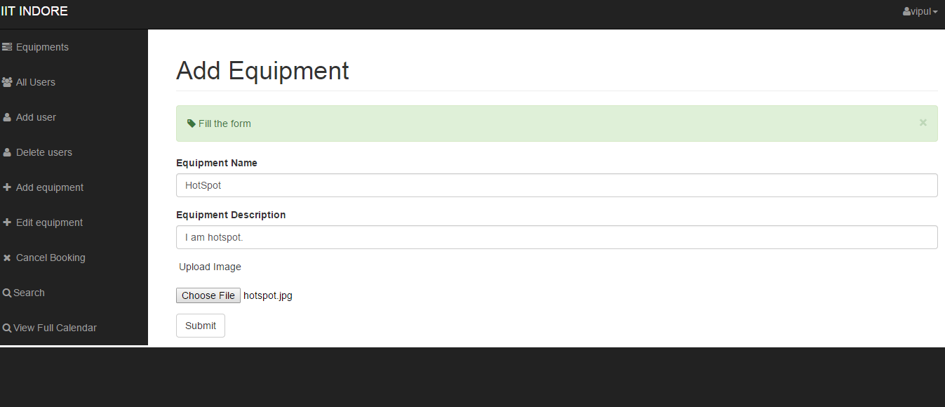

Now file has been chosen. Click Submit.It will show message “  Success! New element added successfully “.

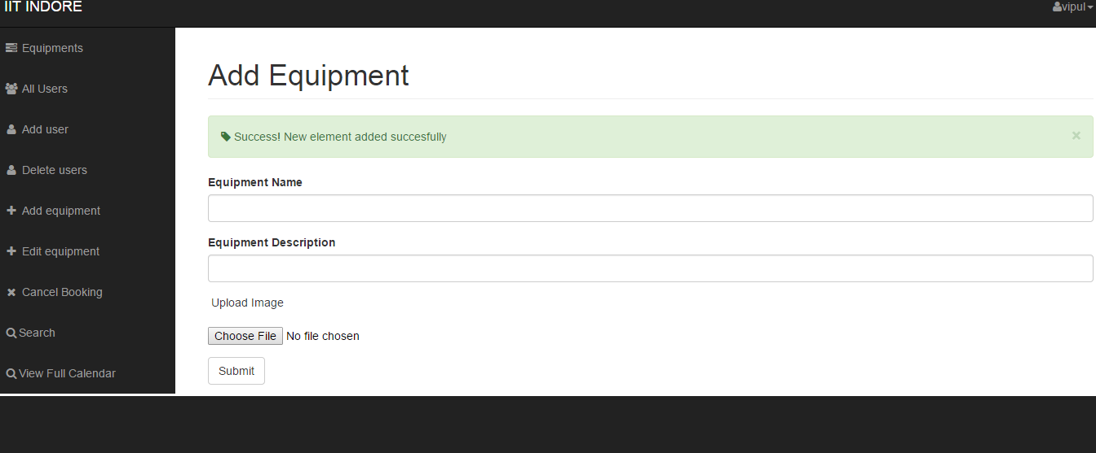

1. “***Edit Equipment***” refers to the page of with Equipments and their details.

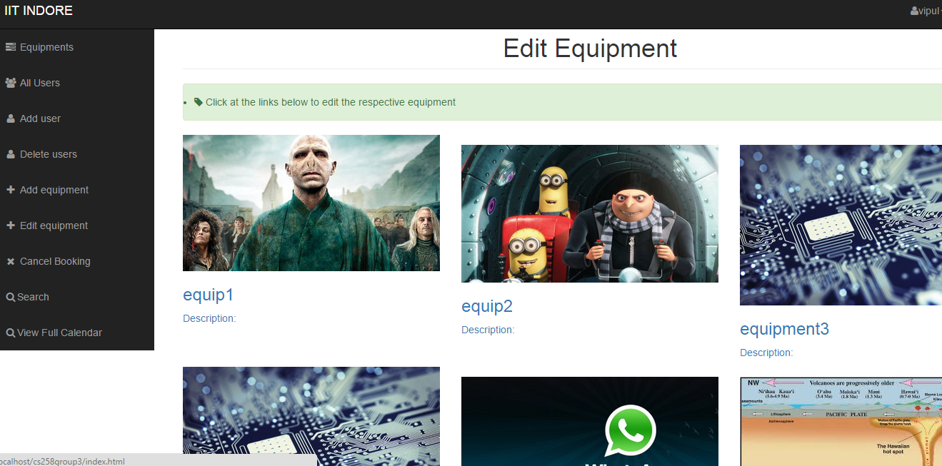

Here Admin can *Add new image of equipment* by choosing appropriate file, can change *Equipment Name and Description*.

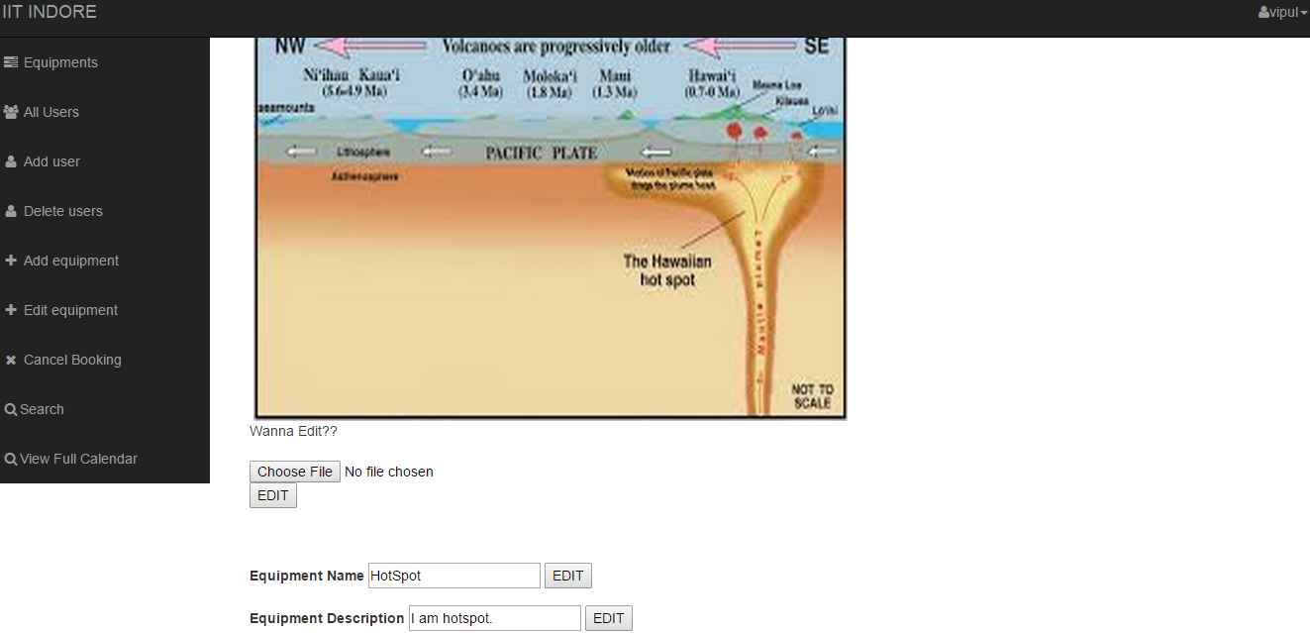

1. “***Cancel Booking***” will show details of booked equipments. Now click on “check to delete” to which you want to delete (one or more can be selected) and click on “cancel selected Booking”. Now requested corresponding booking will be deleted.

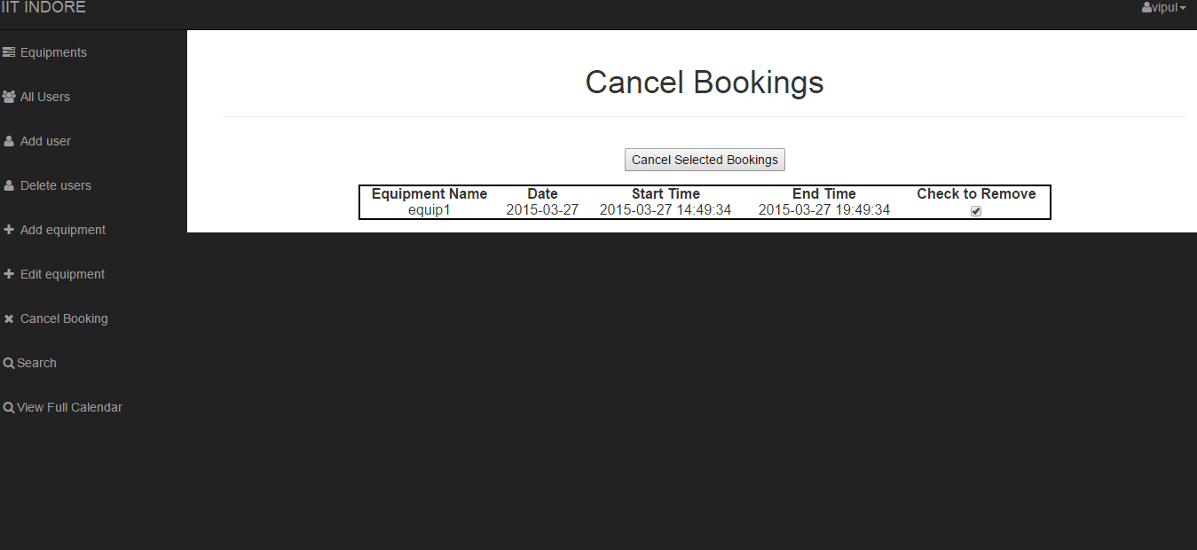

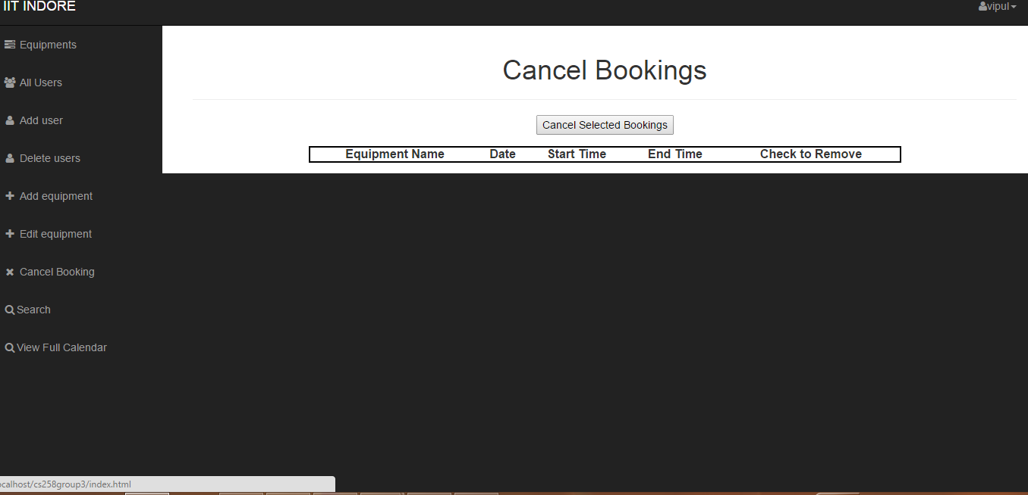

(viii)Clicking on ***Search*** option you can go to the page from where you can search details of an equipment by its name . you can also search the equipments used by an user by his/her name.

(ix)Clicking on ***View Full Calendar***, you can see the full calendar.

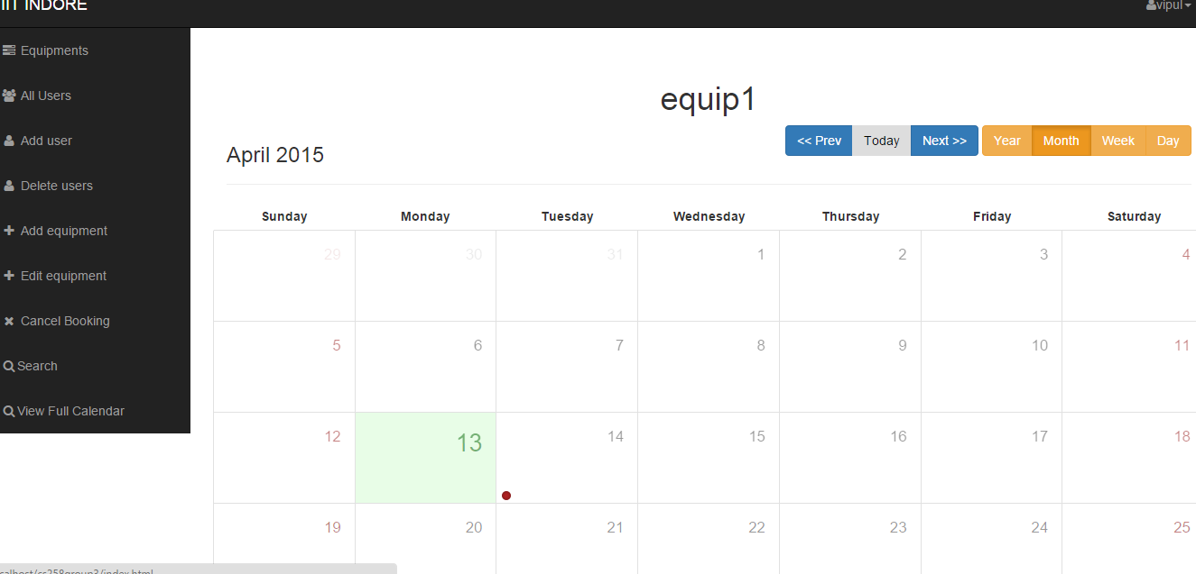

**Functionalities which can be performed by Users**

**2**.**USER LOGIN**

**a.**

**TITLE: Accessing the login page**

Given that the User is on the main web page, there shall be a login button on this page. Clicking on the login button takes the User to the main login page.

**b.**

**TITLE: Logging In**

If the user is not registered (new user) then go for Sign Up on the same page.

Click on **SIGNUP NOW**. Fill the form opened on the new page.Submit it clicking on **Sign Up** button. Then Success message will be shown but its not complete yet. It requires Admin verification. After verified by Admin User’s account will be Activated.

**c.**

If the user is registered, he can login using his “username” and “password” and select **I am User** . The user then has to press the **SUBMIT** button to send the information for verification and the subsequent login.

Now the Transections performed by the **Users** .But user can perform less transections than Admin.

By clicking on “Submit” button takes User to the main User page where User can perform a number of transections , like, “Search”, ”Cancel Bo0king” etc. Here we have screen shot of this page.

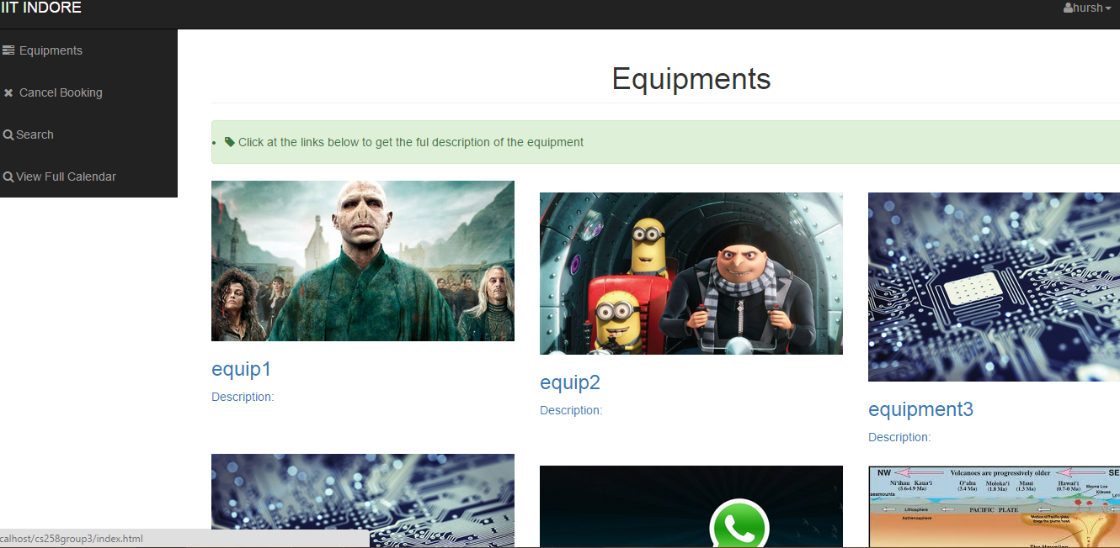

Now on left side of this page, User will have different links for different transections.

1. By clicking on First Link “Equipments” will takes the User on same page.

Here User can click on any equipment.This will take User to the calendar view of the corresponding equipment(current month).Here green coloured box indicates the current date.there are more functionalities also.



1. “***Cancel Booking***” will show details of booked equipments. Now click on “check to delete” to which you want to delete (one or more can be selected) and click on “cancel selected Booking”. Now requested corresponding booking will be deleted.

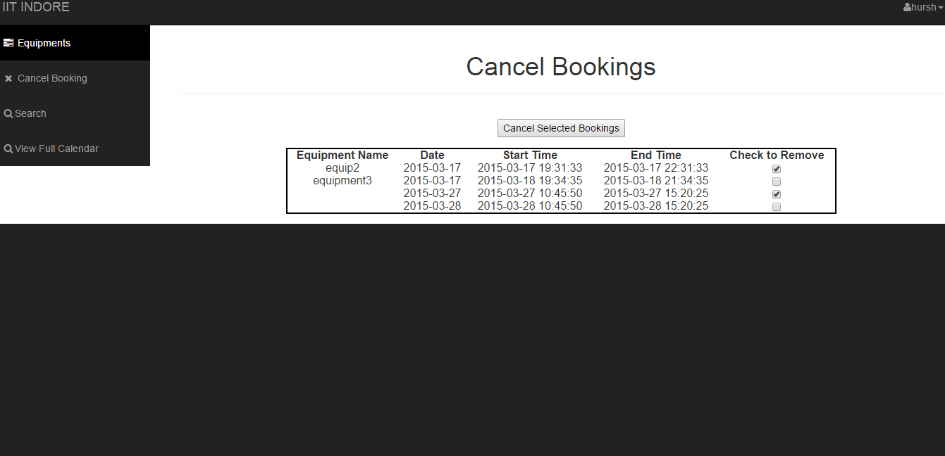

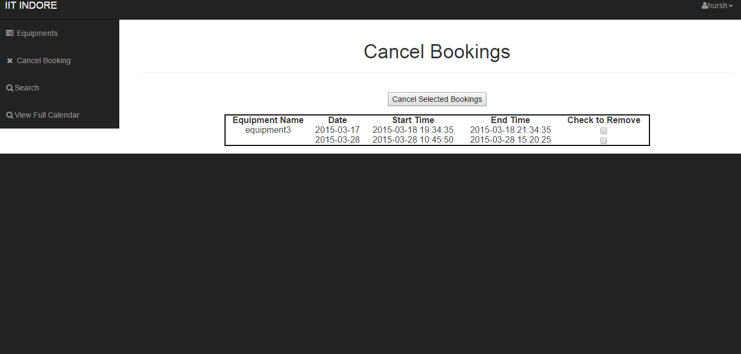

1. Clicking on ***Search*** option you can go to the page from where you can search details of an equipment by its name . you can also search the equipments used by an user by his/her name.
2. Clicking on ***View Full Calendar***, you can see the full calendar.

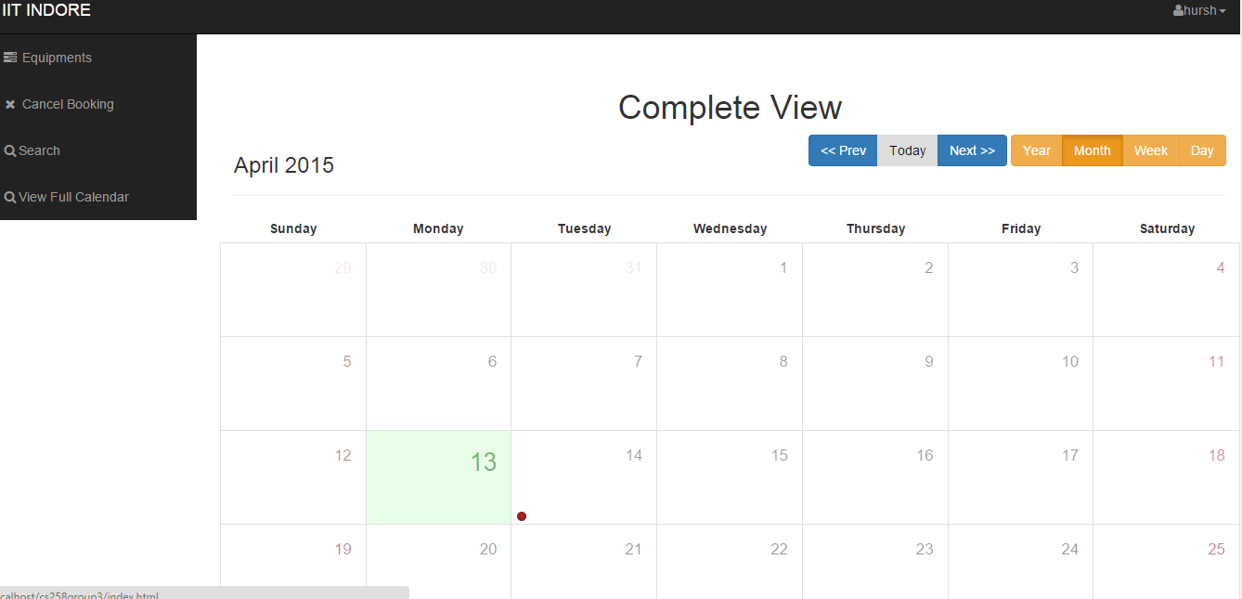

**User Manual Ends.**